Car Rental Application Machine

1. Introduction
The Car Rental Application provides customers and agents with an online portal to search vehicles, make and manage bookings, update account details, and process payments. During a recent security review, two web vulnerabilities were identified that pose material risk to user accounts and business operations: Cross-Site Scripting (XSS) and Cross-Site Request Forgery (CSRF) affecting the login and session flows.
- XSS (Cross-Site Scripting): Vulnerabilities that allow attacker-controlled scripts to run in the context of the victim’s browser. In this application, XSS can be used to execute malicious JavaScript in authenticated users’ sessions, potentially enabling session theft, UI manipulation, or coerced actions.
- CSRF (Cross-Site Request Forgery): An attack where a victim’s browser is coerced into sending authenticated requests to the car-rental backend (for example, the Login.php/booking endpoints) without the user’s intent. A crafted CSRF page can trigger state-changing operations — bookings, cancellations, or account edits — while appearing to come from the legitimate user.
These weaknesses together increase the effective attack surface: XSS can be leveraged to bypass same-origin protections or steal tokens, while CSRF can be used to cause unauthorized state changes. The combination elevates both the likelihood and potential impact of account compromise, fraudulent transactions, and reputational damage.

2.Objectives
The primary goal of this walkthrough is to document, detect, and mitigate the identified XSS and CSRF weaknesses in the Car Rental Application so that the service is safe for customers and operational risk is reduced.
Specific objectives:
- Describe the vulnerability context — provide clear, non-actionable descriptions of where XSS and CSRF have been observed (login flow, form handlers), the preconditions required, and the potential business impacts.
- Establish detection and logging requirements — define what logs and telemetry are needed to detect attempted or successful exploit attempts (e.g., CSRF token failures, anomalous POST patterns, suspicious Referer headers, unexpected script execution traces).
- Recommend prioritized mitigations — list immediate (quick wins), short-term, and long-term technical fixes (cookie hardening, server-side CSRF tokens, input validation/encoding frameworks, content security policy).
- Provide safe testing guidance — offer a controlled methodology for validating fixes in a test environment that avoids harmful exploit use on production systems.
- Map to standards and response playbooks — align findings to CWE/CAPEC/MITRE ATT&CK where relevant, and prescribe an incident response checklist for suspected abuse.
- Enable stakeholders — produce copyable artifacts for ops/dev teams and leadership: remediation steps, SIEM rule templates, and user-notification language if required.

3.Storyline
This storyline is written as a defensive narrative to help stakeholders visualize how the vulnerability could be abused and what consequences to expect — it intentionally omits exploit detail.
- Initial Conditions
  - A customer (Alice) frequently uses the Car Rental web portal from her browser. She has an active authenticated session and saved payment/booking information.
  - The application’s login and booking endpoints accept state-changing POSTs but lack consistent server-side verification for request origin and do not enforce robust anti-CSRF tokens. Some input fields displayed in the UI are not consistently encoded, exposing potential XSS vectors.
- Attacker Motivation & Preparation
  - An attacker’s objective is financial fraud and account manipulation: create or modify bookings to generate chargeable transactions, change contact/payment details to redirect refunds, or cause reputational harm.
  - The attacker crafts two tools: (a) a malicious web page that auto-submits requests to the car-rental endpoints (CSRF-style) and (b) a content vector that, if injected into user-facing pages, can run script in the victim’s browser (XSS-style).

- Exploitation Flow (High-Level)
  - The attacker lures Alice to a third-party page (phishing link, ad, or compromised site) that will attempt to submit POST requests to the car-rental application while Alice’s browser still holds active session cookies. Because the site lacks server-side CSRF validation and cookies are permissive, the backend treats the forged requests as legitimate and executes state changes (e.g., new booking, cancellation, or profile update).
  - Separately, if the attacker can inject script into pages Alice later visits (via XSS), that script may read or manipulate content in Alice’s session, escalate the ability to force actions, or exfiltrate session-identifying data to the attacker, making subsequent CSRF-style actions more potent.
- Impact
  - User harm: unauthorized bookings, unexpected charges, loss of control over account settings, and privacy exposure.
  - Business harm: chargebacks, customer support overhead, inventory inaccuracies (double-booked cars), regulatory or contractual repercussions, and reputational damage.
  - Operational impact: increased incident response workload, emergency patches, and possible downtime or rollback of features.
- Detection & Response Trigger
  - Indicators include an abnormal surge of POST requests to Login.php or booking endpoints originating from external referers, CSRF token verification failures, user reports of unexpected bookings, or log entries showing script execution anomalies in client telemetry.
- Defensive Outcome
  - With the fixes in place (server-validated anti-CSRF tokens; properly encoded/validated output; CSP and cookie hardening; stricter referer/origin checks; re-auth for high-value operations), the attack paths close. CSRF attempts will fail server-side and XSS injection vectors will be neutralized or contained, restoring the integrity of user actions and protecting business processes.

4.Walkthrough
- CSRF ATTACK
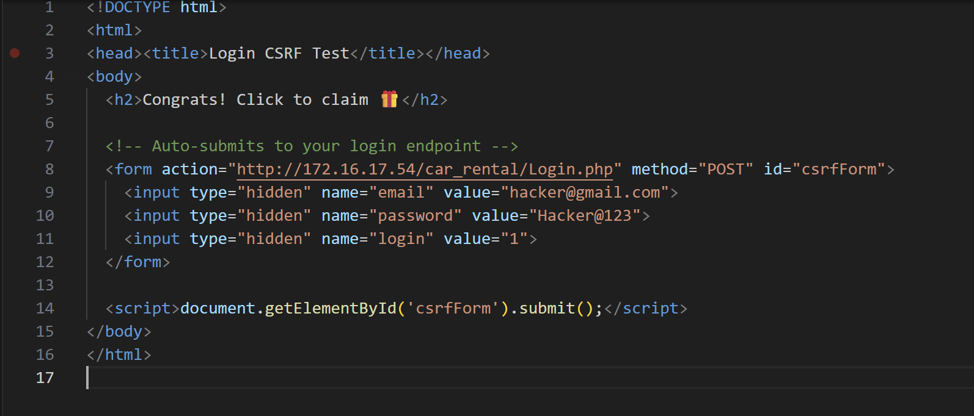

What it is: a malicious web page that automatically sends a login request (an HTTP POST) to the car-rental site’s login endpoint on behalf of anyone who opens the page in their browser.
How it works (conceptually): the attacker’s page contains a form or request pointed at .../Login.php and auto-submits it. If a victim is already authenticated (or the site accepts the supplied credentials), the browser will include cookies/session tokens and the request may be accepted as legitimate.
The attacker’s goal: cause the victim’s browser to perform an action on the target site without the victim’s informed consent — e.g., force a login, change a booking, trigger a booking/cancellation, or perform other side-effects that the logged-in user is allowed to do.
Why it succeeds on vulnerable sites: the target site trusts browser-supplied authentication (cookies or session) and does not verify that requests came from a legitimate site/form (no CSRF token, missing SameSite cookie, or no origin/referer checks).
Risks / impact: unauthorized transactions, data changes, account takeover scenarios, fraudulent bookings/payments, and privacy breaches. For multi-step operations it can be used in combination with other flaws to escalate damage.
Why it’s malicious / not okay: this page is an exploit; using it against systems you don’t own or without explicit permission is illegal and unethical.
Immediate defensive takeaway: require and verify anti-CSRF tokens (per-session or per-form), set cookies with SameSite/HttpOnly/Secure, validate Origin/Referer, and avoid side-effects on GET requests.

- XSS ATTACK
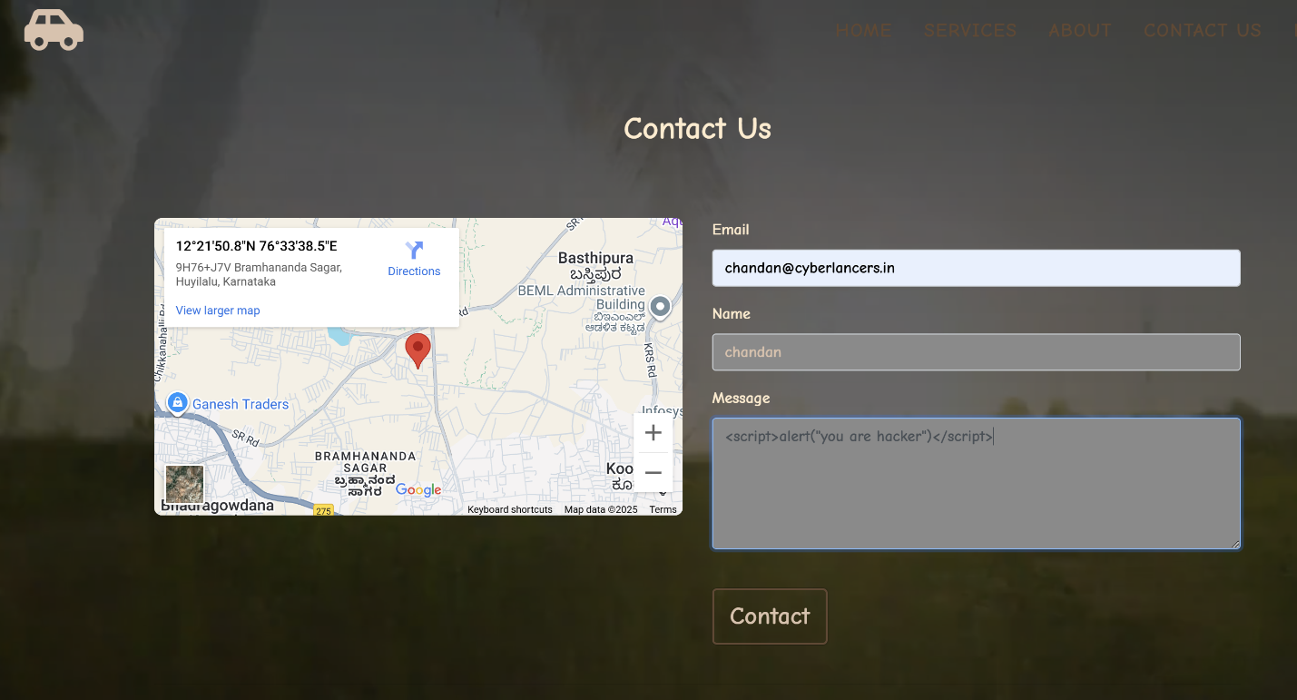

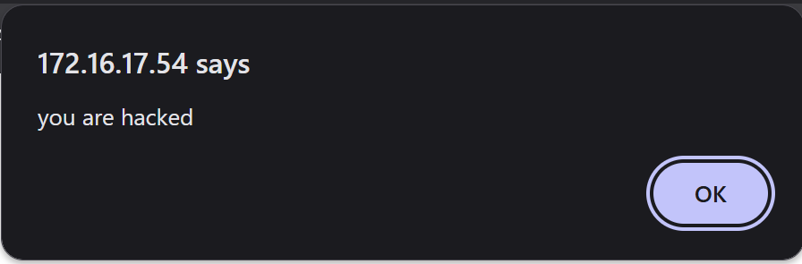
Vulnerability Description
The Contact Us form in the Car Rental application accepts unvalidated input in the Message field. When a user submits a crafted payload (e.g., <script>alert("you are hacker")</script>), the application directly reflects it back into the response without proper output encoding. This leads to execution of arbitrary JavaScript in the victim’s browser.
The second screenshot shows a JavaScript alert() pop-up stating “you are hacked” triggered from the injected payload — confirming that XSS is present.

Attack Scenario / Storyline
- An attacker enters malicious JavaScript into the Message field of the Contact form.
- The backend stores or reflects the raw input without sanitization/encoding.
- When the form response or admin dashboard displays the submitted message, the malicious script executes in the victim’s browser.
- Depending on attacker intent, the script could:
  - Steal session cookies or tokens,
  - Deface the site,
  - Redirect users to phishing pages,
  - Perform actions on behalf of authenticated users,
  - Deliver further payloads (e.g., keyloggers).

Business / Security Impact
- Confidentiality: Attacker can exfiltrate session IDs, account details, or booking information.
- Integrity: Malicious scripts can alter displayed booking or payment details, misleading users or staff.
- Availability / Reputation: Pop-ups, defacements, or malicious redirects degrade trust and can cause customers to abandon the site.
- Combined Risk with CSRF: Attackers could combine XSS with CSRF to bypass token protections, increasing impact.

5. Mitre Tactics and Techniques
MITRE Tactic | Technique (concise) | Relevance to XSS / CSRF
Initial Access | Drive-by Compromise (malicious page delivers CSRF/XSS) | Attacker lures victim to attacker page that triggers CSRF requests or delivers XSS payloads.
Initial Access | Exploit Public-Facing Application | Targeting the web app’s input handling or endpoints to find XSS/CSRF weaknesses.
Execution | Client-side Script Execution (XSS) | Stored/reflected XSS runs attacker JS in victims’ browsers, enabling further actions.
Credential / Session Access | Session Token Theft via XSS | XSS can exfiltrate cookies or tokens enabling session hijacking and impersonation.
Persistence | Account Manipulation / Recovery Alteration | CSRF/XSS used to change recovery email/phone or add attacker-controlled contact details.
Defense Evasion | Abuse of Browser Trust / Missing Origin Checks | CSRF exploits automatic cookie behavior; missing Origin/Referer checks let forged requests through.
Impact | Manipulation / Fraudulent Transactions | CSRF forces bookings/changes; combined with XSS enables fraudulent transactions and data corruption.

6.Conclusion

The Car Rental application’s exposed XSS in the Contact form and lack of robust CSRF protections on login/state endpoints together create a high-risk chain: XSS allows client-side script execution that can steal session artifacts and bypass same-origin defenses, while CSRF permits forced state changes using a victim’s authenticated browser. Combined, these weaknesses enable account manipulation, fraudulent transactions, and data exfiltration with meaningful business impact. Remediate urgently by applying cookie hardening, implementing server-validated CSRF tokens, enforcing output encoding and a strict Content Security Policy, and adding monitoring for CSRF token failures and anomalous bookings. Prioritize fixes as above, validate in a test environment, and follow with a targeted verification scan and incident-response playbook to ensure resilience.

